Developing Applications with Augmented Reality Techniques using Unity3D and Vuforia

Xinqi Liu, Dong-Won Park

PaiChai University, Daejeon, Korea

Augmented reality based upon mobile terminal is the hot topic of concern in mobile applications and human-machine interaction. Mobile augmented reality combine the intelligent display,registration tracking , virtual and reality fusion and human-computer interaction technologies via hand-held devices or intelligent terminals. It enables the 3D virtual object to dock seamlessly with the real scene of customer, thereby enlarging the cognitive range. This paper produces a three-dimensional model of the scene by utilizing Unity 3D modeling and detects and tracks features of totems from the Vuforia engine. It can set animation and play videos.Moreover, the interaction between the virtual and reality can be generated in virtue of the virtual button. AR ( full name: augmented reality ) application of the Vuforia SDK is the hub connecting the virtual world and the reality. Monitors of mobile terminal merge actual video and virtual objects together, thus three-dimensional tracking and registration can be realized. This paper introduces the application of AR technology in the unity 3d environment through designing a game.

Keywords: augmented reality; interaction between the virtual and reality; image recognition; three-dimensional registration; Unity 3D;

**I. Introduction**

Augmented reality is a new technology evolving from virtual reality. This method mainly enhances the user's perception of the real world based on the information offered by computer system and reality can be “augmented”by means of overlaying the computer-generated virtual objects, scenarios and system prompts to the real scene. It primarily assists human beings in displaying the unreachable scenes in the real world.

Vuforia augmented reality software development kit ( English: Vuforia Augmented Reality SDK ) is designed by Qualcomm for augmented reality applications of mobile devices mobile devices. It identifies and captures planar images or simple three-dimensional objects ( such as boxes ) timely by means of computer vision technology. Then it permits developers placing virtual objects through camera viewfinder and adjusting its position on the front of the lens.

Augmented reality ( AR) is a new technology that integrates the real world and virtual one information seamlessly. The physical information ( visual information, sound, taste, smell, etc. ) that is not easy to experience in the real world in a certain time and space is simulated and superimposed by using computer science and technology. Virtual information is applied to the real world and perceived by human beings . So the experience surpassing the reality is achieved. Real environment and virtual objects are superimposed on the same screen or space in real time.

Augmented reality contains various technology multimedia, 3D modeling, real-time video display and management ,fusion of multiple sensors, real-time tracking and registration, scene combination and other new technologies and new tools. Augmented reality provides information that is disparate from human perception in half of the cases.

This paper researches the application of Unity 3D-the integrated game development tool of multiple platform. It employs the mobile device augmentation of the real application software development kit developed by Qualcomm. People can experience AR ( Augmented Reality ) which is also known as the hybrid reality in the Unity 3D environment. The application of AR technology in Unity 3D can be reflected through the design of a game and the basic use of enhancing the reality can be researched.

**II. Basic Applications of Unity3D-Vuforia in AR**

The typical augmented reality application is principally composed of off-line and online processing. The off-line processing covers the selection and treatment of identification objects in advance , geometric model of objects in the virtual world, establishment of physical model, generation of behavior model and three-dimensional scene. This part is mainly completed by unity 3d. The online one also includes identification of objects and produces the corresponding feedback information in real time. in the real scene. The virtual object is added to reality and the human-computer interaction is realized. This process is chiefly accomplished by Vuforia SDK.

**2.1 Unity3D**

Unity 3D is a cross-platform integrated 3D game engine developed by Unity Technologies Co.Ltd. It can superpose the virtual onto reality and realizes human-computer interaction with some augmented reality development tools. It allows Vuforia SDK extension plug - ins to detect and track under the corresponding ports and creates AR applications and games. It provides ample development box functions to create games and other interactive 3D content. Unity 3D can append sunlight, fog, wind, sky box, water and other physical materials, ambient sound and animated video to the virtual scene. Meanwhile, you can browse, test and edit 3D application scenarios. Also it is available to release to the required platforms, such as Windows, iOs, Android and so on.

**2.2 Vuforia SDK**

Vuforia SDK is an augmented reality software development kit for mobile devices launched by  Qualcomm. It utilizes computer vision technology to recognize and capture planar images or 3D objects in real time and permits developers placing virtual objects through the viewfinder of the camera and adjusting the position of objects on the background of the camera. Vuforia SDK supports kinds of types of 2D and 3D objects including multiple target configurations, images with fewer symbol and frame tags. There is an added function in the SDK. It takes advantage of virtual buttons to detect localized occlusion. Moreover it can select and reconfigure the target image in real time and create a target set according to the scheme. The data flow diagram of the Vuforia SDK is shown in figure 1.

Figure 1 Data flow diagram of Vuforia SDK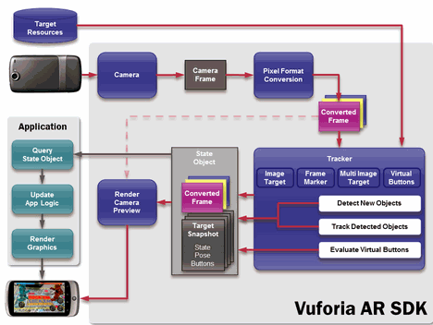

The data stream of Vuforia SDK is divided into four modules: inputting, database,tracking and matching and render output.

Mobile phones can seize images of each frame in the present real scene through the camera and then matches identification objects in the database timely according to the pixel format conversion. After that, it adds preset virtual objects such as 3d model, animation or video to real scenes. It can also interact with these virtual objects, render and output information at mobile terminals.

**III. Environment Development and Production Process of AR Tower Defense Game**

**3.1 Establishment of the Environment**

1. Download development resource: Unity 3D5.5.0 and then install.
2. Download the Vuforia QCAR development plug - ins.
3. Create the identification object on Vuforia net:

1. Create license: click Develop on the development home page of Qualcomm Vuforia and then Add License Key on License Manager. Select Development and name App First. The object is generated.

2. Create Database: Click Add Database on Target Manager and name cube. Thus the creation is completed.

3. Create Target: select the cube that has just been created. Establish the identification target. Elect Single Image and the picture path. Set the picture width and complete the creation.

4. Download and create a good identification target. As shown in figure 2.



Figure 2. Creation of Identification Object on Vuforia. Net

**3.2 Process of AR Tower Defense Game Generation**

(1)Create a new engineering project in unity.

(2)Download the Vuforia - unity - 6 - 2 - 10, Unity package plug-ins on Vuforia.

(3)Import the Vuforia plug-ins in unity and the downloaded unitypackage file

(4)After importing, Plugins folder and Vuforia appear will appear under the Asset directory. Delete the Main Camera in Hierarchy and then drag the ARCamera and Image Target under the Vuforia /Prefabs directory to the scene.

(5)Select AR Camera in Hierarchy to view the Inspector window. Click Open Vuforia Configuration in Inspector window and fill in the App LinceSE Key. Enter the Vuforia website. Locate the established Lincese Key. Copy it to Unity and alter other parameter settings.

(6)Select the Image Target in Hierarchy to view the insperctor window. Click database in Image Target Behavior and choose the unity package file just imported; Click Image Target again and elect the target image contained in the import file.

(7)Add the required 3D model to Hierarchy. Drag the model into the Image Target and become an auxiliary object of the Image Target. Change the parameter settings related to each model.

(8)Add UI settings to Hierarchy then select it. Click the Canvas and create it. Create a subsidiary object in the canvas to get command of the disparate display in the game including enemy killed points and scores displayed, player's hit points , equipment options ( laser weapons and bullets, respectively ), bullet buttons and so on.

(9)Create the script GameManager and UI Manager functions. They have several roles including UI display, weapon switching, monster generation waves and numbers, monster generation interval, laser damage and so on. Monster in tower defense game usually arises in batches. For they are numerous, a monster generator is essential to produce diverse monsters in the order set in advance.

(10)Create a script Ctrl_Bullet function in the Bullet under the Canvas and set the player's bullet damage.

(11)Create the Enemy Ctrl function in the warrior, set attack and monster movement speed,monster damage and attack interval as illustrated in figure 3.

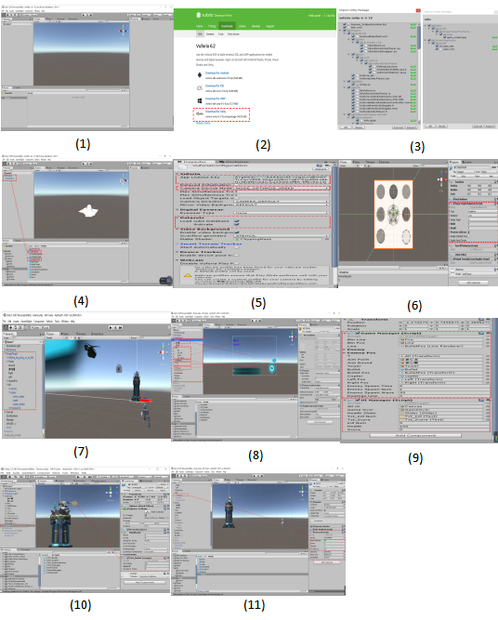Figure 3 Fabrication Process of AR Tower Defense Game

**3.3 Game generation**

This paper develops an AR tower tower game adding the virtual object to the real scene. When the camera lens position varied from the former one, the relative position and angle between the camera and the real scene also transform accordingly. Since the matching images are tracked, the application can accurately [apperceive](http://www.baidu.com/link?url=VlcilY2hXpoxSP2uDBjgtL8j9wHOOulMCyKbkL3awtTt0vOr37khFGpIBlmxrORrCkgkvgxV8yTZ8mGOe5xfMJKqNz38PJ8oGyo14tEvugS) these changes and react correspondingly. The virtual objects superposed onto the real scene will also alter in line with changes of position and angle of the camera. If the matching image disappears from the camera lens, the virtual object will vanish. As is shown in figure 4.

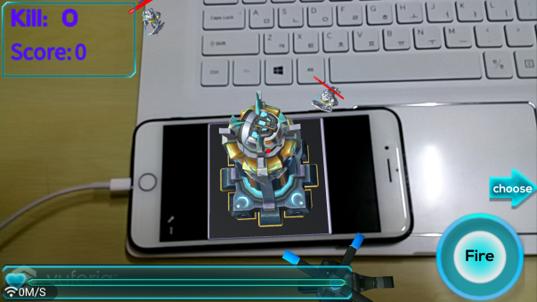

Figure 4 Game Generating Version

**IV. Conclusion**

This paper emphasizes the unity 3d technology and Qualcomm QCAR development tool--Vuforia and then introduces the basic concepts and framework. Based on this, the three-dimensional model of scene is simulated by the means of Unity 3d. The Vuforia engine can detect and track identification features and fabricate corresponding 3D model in accordance with the relative position and attitude information of sundry identifiers on the visual plane, the corresponding 3d model. It can set animation, play video and interact the virtual and reality via virtual button mode. Furthermore, the whole process of the game environment can be displayed. Images fused after multi-angle observation make the experimental effect more vivid and almost real. The real-time synchronization satisfies the users in the real world to feel the virtual space, thus strengthening the spice and interaction.

## Reference

[1]朱柱. 基于Unity3D的虚拟实验系统设计与应用研究[D]. 华中师范大学, 2012.

[2]韩睿睿. 基于Unity3D的增强现实技术研究[D]. 西安电子科技大学, 2013.

[3]顾嘉伟, 张艳鹏, 曹大元,等. 基于Unity3D与AR技术的虚拟实验系统设计与仿真[J]. 2014.

[4]罗永东. 基于Unity3D的移动增强现实技术与应用研究[D]. 青岛科技大学, 2015.

[5]罗永东, 张淑军. 一种基于 Unity3D 的移动增强现实自动导览方法[J]. 计算机与数字工程, 2015(11):2024-2028.

[6]吕朝辉, 阳星芸, 张岳,等. 结合传感器与Unity3D的定点移动增强现实方法:, CN105023294A[P]. 2015.

[7]李洁. 基于Android平台的增强现实系统研究与应用[D]. 河北农业大学, 2015.

[8]徐敏, 童强, XUMin,等. 一种基于Unity3D+Vuforia的增强现实交互App的开发[J]. 现代计算机, 2016(12):71-75.

[9]Cushnan, Dominic. Developing AR games for iOS and Android develop and deploy augmented reality apps using Vuforia SDK and Unity 3D[J]. 2013.

[10]吕朝辉, 阳星芸, 张岳, et al. Fixed point movement augmented reality method combining sensors and Unity3D:, CN 105023294 A[P]. 2015.

[11]Kim S L, Suk H J, Kang J H, et al. Using Unity 3D to facilitate mobile augmented reality game development[C]// Internet of Things. IEEE, 2014:21-26.

[12]Pauley D B, Worley C S B, Liljegren E A, et al. Augmented reality presentation:, US9165318[P]. 2015.